Pentatonic Scale across the Neck (3 + 2 pattern)

Basic five note pattern shape Basic five note pattern on the guitar neck with fingering
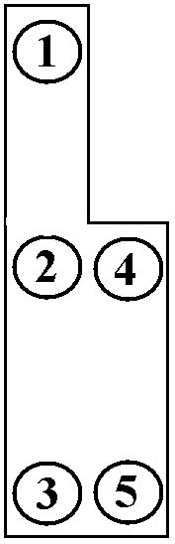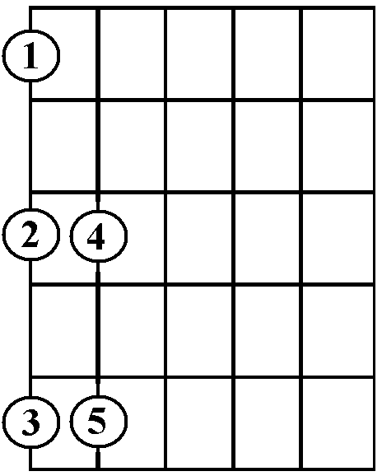

Basic five note pattern repeated Basic five note pattern repeated
and joined together and joined together on the guitar neck with fingering

Ascending fingering Descending fingering

